UNITED STATES
SECURITIES AND EXCHANGE COMMISSION
Washington, D.C. 20549
Form 8-K
CURRENT REPORT
Pursuant to Section 13 or 15(d) of the Securities Exchange Act of 1934
Date of Report (Date of earliest event reported): August 27, 2026
IREN LIMITED
(Exact name of registrant as specified in its charter)
Commission File Number: 001-41072

Australia |  |  |  |  |  | Not Applicable
(State or other jurisdiction of  incorporation) |  |  |  |  |  | (IRS Employer  Identification No.)
Level 5, 55 Market Street, Sydney, NSW 2000 Australia
(Address of principal executive offices, including zip code)
+61 2 7906 8301
(Registrant’s telephone number, including area code)
(Former name or former address, if changed since last report)
Check the appropriate box below if the Form 8-K filing is intended to simultaneously satisfy the filing obligation of the registrant under any of the following provisions:
☐ |  |  | Written communications pursuant to Rule 425 under the Securities Act (17 CFR 230.425)
☐ |  |  | Soliciting material pursuant to Rule 14a-12 under the Exchange Act (17 CFR 240.14a-12)
☐ |  |  | Pre-commencement communications pursuant to Rule 14d-2(b) under the Exchange Act (17 CFR 240.14d-2(b))
☐ |  |  | Pre-commencement communications pursuant to Rule 13c-4(c) under the Exchange Act (17 CFR 240.13e-4(c))
Securities Registered Pursuant to Section 12(b) of the Act:
Title of each class |  |  |  |  |  | Trading symbol(s) |  |  |  |  |  | Name of each exchange on which registered
Ordinary shares, no par value |  |  |  |  |  | IREN |  |  |  |  |  | The Nasdaq Stock Market LLC
Indicate by check mark whether the registrant is an emerging growth company as defined in Rule 405 of the Securities Act of 1933 (§230.405 of this chapter) or Rule 12b-2 of the Securities Exchange Act of 1934 (§240.12b-2 of this chapter).
Emerging growth company ☐
If an emerging growth company, indicate by check mark if the registrant has elected not to use the extended transition period for complying with any new or revised financial accounting standards provided pursuant to Section 13(a) of the Exchange Act. ☐

Item 2.02 |  |  | Results of Operations and Financial Condition.
On August 27, 2026, IREN Limited (the “Company”) reported its financial results for the fourth quarter and fiscal year ended June 30, 2026. A copy of the related press release is furnished herewith as Exhibit 99.1 and is incorporated herein by reference.
The information contained in this Item 2.02 and Exhibit 99.1 attached hereto shall not be deemed to be “filed” for purposes of Section 18 of the Securities Exchange Act of 1934, as amended (the “Exchange Act”), or otherwise subject to the liabilities of that section, nor shall it be deemed incorporated by reference in any filing under the Securities Act of 1933, as amended, or the Exchange Act, except as shall be expressly set forth by specific reference in such filing.
Item 9.01 |  |  | Financial Statements and Exhibits.
(d) |  |  | Exhibits
Exhibit No. |  |  |  |  |  | Description
99.1 |  |  |  |  |  | Press Release, dated August 27, 2026, issued by IREN Limited.
104 |  |  |  |  |  | Cover Page Interactive Data File (embedded within the Inline XBRL document)

SIGNATURES
Pursuant to the requirements of the Securities Exchange Act of 1934, the registrant has duly caused this report to be signed on its behalf by the undersigned hereunto duly authorized.
IREN LIMITED
By: |  |  | /s/ William Roberts
William Roberts
Co-Chief Executive Officer and Director
Date: 27 August 2026
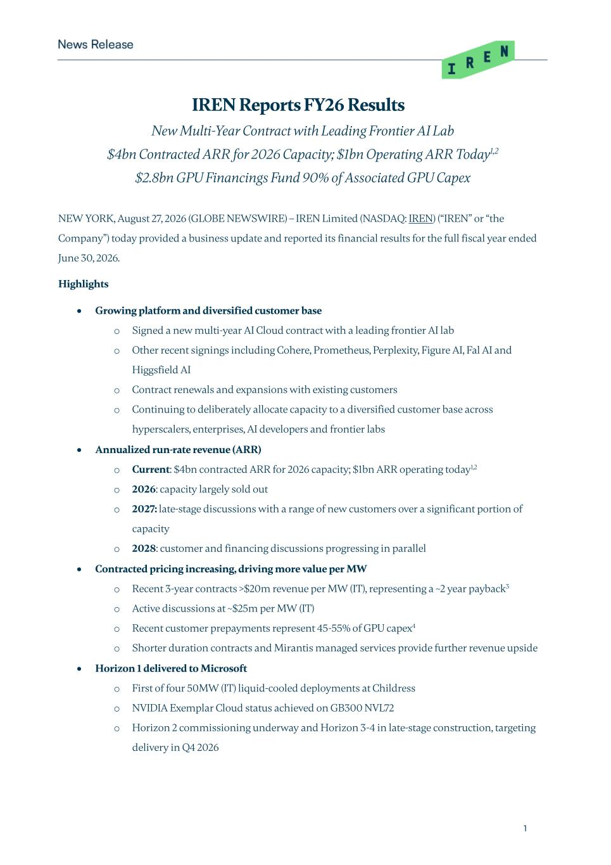

1 IREN Reports FY26 Results New Multi-Year Contract with Leading Frontier AI Lab $4bn Contracted ARR for 2026 Capacity; $1bn Operating ARR Today1,2 $2.8bn GPU Financings Fund 90% of Associated GPU Capex NEW YORK, August 27, 2026 (GLOBE NEWSWIRE) – IREN Limited (NASDAQ: IREN) (“IREN” or “the Company”) today provided a business update and reported its financial results for the full fiscal year ended June 30, 2026. Highlights • Growing platform and diversified customer base o Signed a new multi-year AI Cloud contract with a leading frontier AI lab o Other recent signings including Cohere, Prometheus, Perplexity, Figure AI, Fal AI and Higgsfield AI o Contract renewals and expansions with existing customers o Continuing to deliberately allocate capacity to a diversified customer base across hyperscalers, enterprises, AI developers and frontier labs • Annualized run-rate revenue (ARR) o Current: $4bn contracted ARR for 2026 capacity; $1bn ARR operating today1,2 o 2026: capacity largely sold out o 2027: late-stage discussions with a range of new customers over a significant portion of capacity o 2028: customer and financing discussions progressing in parallel • Contracted pricing increasing, driving more value per MW o Recent 3-year contracts >$20m revenue per MW (IT), representing a ~2 year payback3 o Active discussions at ~$25m per MW (IT) o Recent customer prepayments represent 45-55% of GPU capex4 o Shorter duration contracts and Mirantis managed services provide further revenue upside • Horizon 1 delivered to Microsoft o First of four 50MW (IT) liquid-cooled deployments at Childress o NVIDIA Exemplar Cloud status achieved on GB300 NVL72 o Horizon 2 commissioning underway and Horizon 3-4 in late-stage construction, targeting delivery in Q4 2026

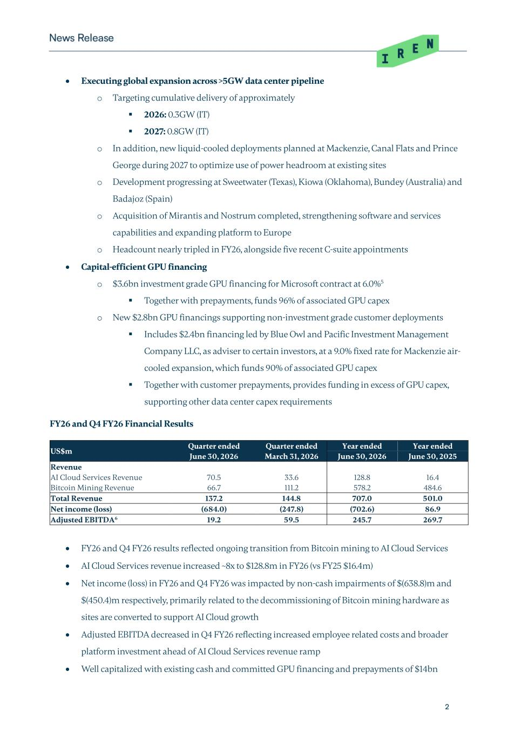
2 • Executing global expansion across >5GW data center pipeline o Targeting cumulative delivery of approximately ▪ 2026: 0.3GW (IT) ▪ 2027: 0.8GW (IT) o In addition, new liquid-cooled deployments planned at Mackenzie, Canal Flats and Prince George during 2027 to optimize use of power headroom at existing sites o Development progressing at Sweetwater (Texas), Kiowa (Oklahoma), Bundey (Australia) and Badajoz (Spain) o Acquisition of Mirantis and Nostrum completed, strengthening software and services capabilities and expanding platform to Europe o Headcount nearly tripled in FY26, alongside five recent C-suite appointments • Capital-efficient GPU financing o $3.6bn investment grade GPU financing for Microsoft contract at 6.0%5 ▪ Together with prepayments, funds 96% of associated GPU capex o New $2.8bn GPU financings supporting non-investment grade customer deployments ▪ Includes $2.4bn financing led by Blue Owl and Pacific Investment Management Company LLC, as adviser to certain investors, at a 9.0% fixed rate for Mackenzie air- cooled expansion, which funds 90% of associated GPU capex ▪ Together with customer prepayments, provides funding in excess of GPU capex, supporting other data center capex requirements FY26 and Q4 FY26 Financial Results US$m Quarter ended Quarter ended Year ended Year ended June 30, 2026 March 31, 2026 June 30, 2026 June 30, 2025 Revenue AI Cloud Services Revenue 70.5 33.6 128.8 16.4 Bitcoin Mining Revenue 66.7 111.2 578.2 484.6 Total Revenue 137.2 144.8 707.0 501.0 Net income (loss) (684.0) (247.8) (702.6) 86.9 Adjusted EBITDA6 19.2 59.5 245.7 269.7 • FY26 and Q4 FY26 results reflected ongoing transition from Bitcoin mining to AI Cloud Services • AI Cloud Services revenue increased ~8x to $128.8m in FY26 (vs FY25 $16.4m) • Net income (loss) in FY26 and Q4 FY26 was impacted by non-cash impairments of $(638.8)m and $(450.4)m respectively, primarily related to the decommissioning of Bitcoin mining hardware as sites are converted to support AI Cloud growth • Adjusted EBITDA decreased in Q4 FY26 reflecting increased employee related costs and broader platform investment ahead of AI Cloud Services revenue ramp • Well capitalized with existing cash and committed GPU financing and prepayments of $14bn

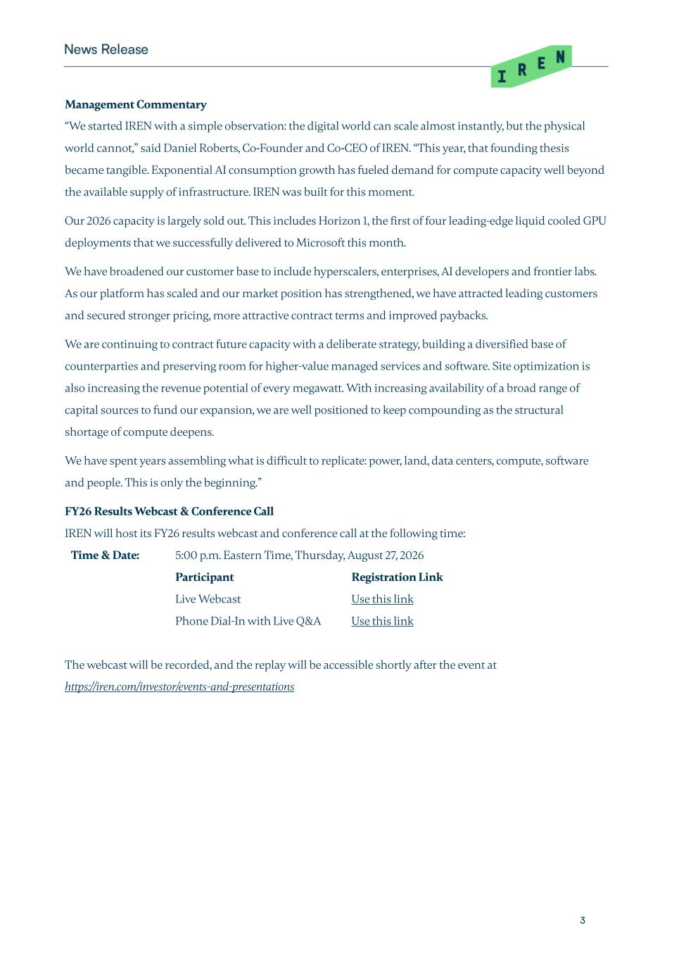
3 Management Commentary “We started IREN with a simple observation: the digital world can scale almost instantly, but the physical world cannot,” said Daniel Roberts, Co-Founder and Co-CEO of IREN. “This year, that founding thesis became tangible. Exponential AI consumption growth has fueled demand for compute capacity well beyond the available supply of infrastructure. IREN was built for this moment. Our 2026 capacity is largely sold out. This includes Horizon 1, the first of four leading-edge liquid cooled GPU deployments that we successfully delivered to Microsoft this month. We have broadened our customer base to include hyperscalers, enterprises, AI developers and frontier labs. As our platform has scaled and our market position has strengthened, we have attracted leading customers and secured stronger pricing, more attractive contract terms and improved paybacks. We are continuing to contract future capacity with a deliberate strategy, building a diversified base of counterparties and preserving room for higher-value managed services and software. Site optimization is also increasing the revenue potential of every megawatt. With increasing availability of a broad range of capital sources to fund our expansion, we are well positioned to keep compounding as the structural shortage of compute deepens. We have spent years assembling what is difficult to replicate: power, land, data centers, compute, software and people. This is only the beginning.” FY26 Results Webcast & Conference Call IREN will host its FY26 results webcast and conference call at the following time: Time & Date: 5:00 p.m. Eastern Time, Thursday, August 27, 2026 Participant Registration Link Live Webcast Use this link Phone Dial-In with Live Q&A Use this link The webcast will be recorded, and the replay will be accessible shortly after the event at https://iren.com/investor/events-and-presentations

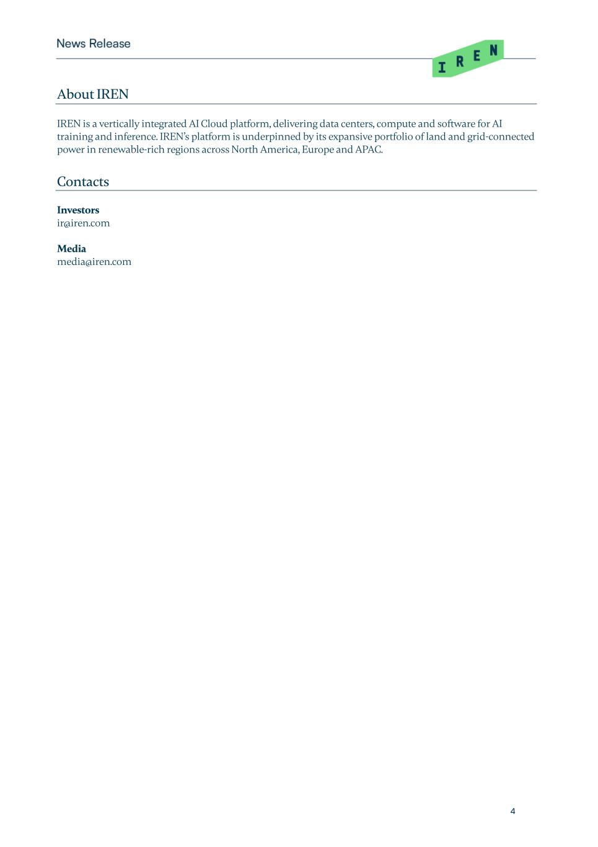
4 About IREN IREN is a vertically integrated AI Cloud platform, delivering data centers, compute and software for AI training and inference. IREN’s platform is underpinned by its expansive portfolio of land and grid-connected power in renewable-rich regions across North America, Europe and APAC. Contacts Investors ir@iren.com Media media@iren.com

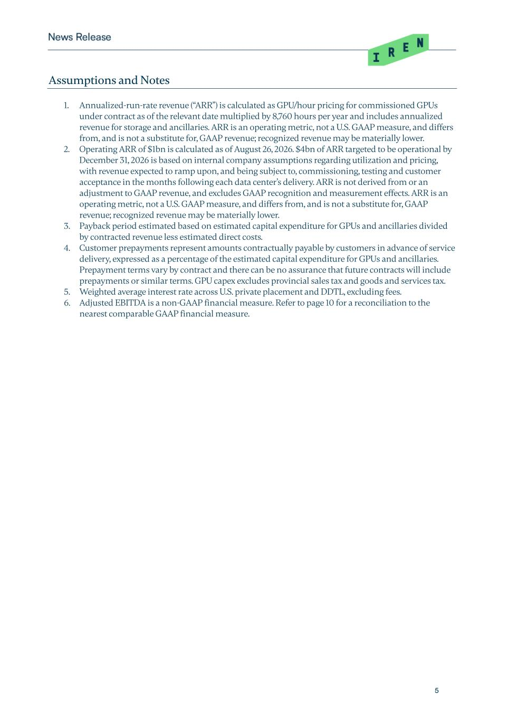
5 Assumptions and Notes 1. Annualized-run-rate revenue (“ARR”) is calculated as GPU/hour pricing for commissioned GPUs under contract as of the relevant date multiplied by 8,760 hours per year and includes annualized revenue for storage and ancillaries. ARR is an operating metric, not a U.S. GAAP measure, and differs from, and is not a substitute for, GAAP revenue; recognized revenue may be materially lower. 2. Operating ARR of $1bn is calculated as of August 26, 2026. $4bn of ARR targeted to be operational by December 31, 2026 is based on internal company assumptions regarding utilization and pricing, with revenue expected to ramp upon, and being subject to, commissioning, testing and customer acceptance in the months following each data center’s delivery. ARR is not derived from or an adjustment to GAAP revenue, and excludes GAAP recognition and measurement effects. ARR is an operating metric, not a U.S. GAAP measure, and differs from, and is not a substitute for, GAAP revenue; recognized revenue may be materially lower. 3. Payback period estimated based on estimated capital expenditure for GPUs and ancillaries divided by contracted revenue less estimated direct costs. 4. Customer prepayments represent amounts contractually payable by customers in advance of service delivery, expressed as a percentage of the estimated capital expenditure for GPUs and ancillaries. Prepayment terms vary by contract and there can be no assurance that future contracts will include prepayments or similar terms. GPU capex excludes provincial sales tax and goods and services tax. 5. Weighted average interest rate across U.S. private placement and DDTL, excluding fees. 6. Adjusted EBITDA is a non-GAAP financial measure. Refer to page 10 for a reconciliation to the nearest comparable GAAP financial measure.

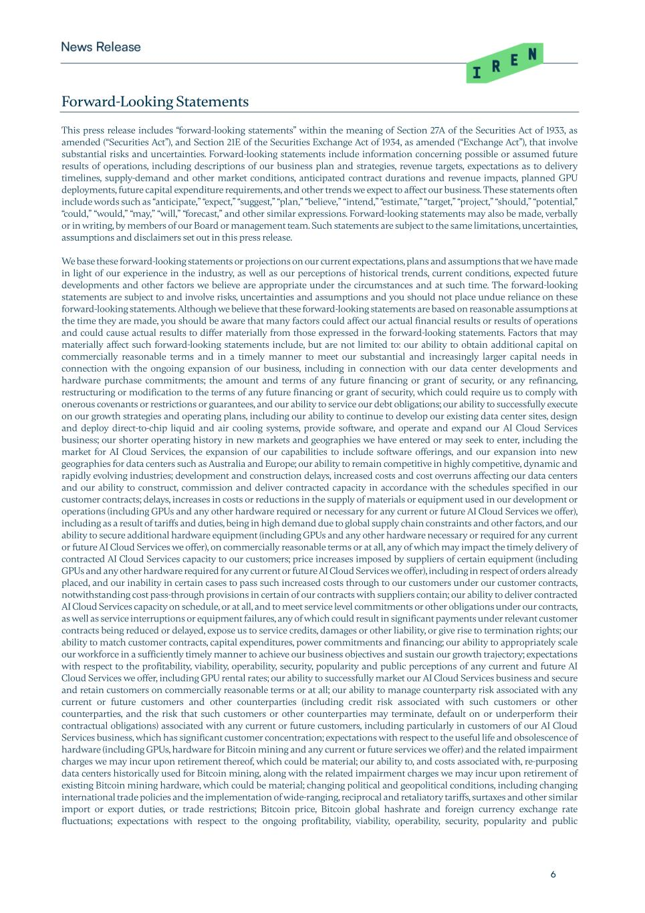
6 Forward-Looking Statements This press release includes “forward-looking statements” within the meaning of Section 27A of the Securities Act of 1933, as amended (“Securities Act”), and Section 21E of the Securities Exchange Act of 1934, as amended (“Exchange Act”), that involve substantial risks and uncertainties. Forward-looking statements include information concerning possible or assumed future results of operations, including descriptions of our business plan and strategies, revenue targets, expectations as to delivery timelines, supply-demand and other market conditions, anticipated contract durations and revenue impacts, planned GPU deployments, future capital expenditure requirements, and other trends we expect to affect our business. These statements often include words such as “anticipate,” “expect,” “suggest,” “plan,” “believe,” “intend,” “estimate,” “target,” “project,” “should,” “potential,” “could,” “would,” “may,” “will,” “forecast,” and other similar expressions. Forward-looking statements may also be made, verbally or in writing, by members of our Board or management team. Such statements are subject to the same limitations, uncertainties, assumptions and disclaimers set out in this press release. We base these forward-looking statements or projections on our current expectations, plans and assumptions that we have made in light of our experience in the industry, as well as our perceptions of historical trends, current conditions, expected future developments and other factors we believe are appropriate under the circumstances and at such time. The forward-looking statements are subject to and involve risks, uncertainties and assumptions and you should not place undue reliance on these forward-looking statements. Although we believe that these forward-looking statements are based on reasonable assumptions at the time they are made, you should be aware that many factors could affect our actual financial results or results of operations and could cause actual results to differ materially from those expressed in the forward-looking statements. Factors that may materially affect such forward-looking statements include, but are not limited to: our ability to obtain additional capital on commercially reasonable terms and in a timely manner to meet our substantial and increasingly larger capital needs in connection with the ongoing expansion of our business, including in connection with our data center developments and hardware purchase commitments; the amount and terms of any future financing or grant of security, or any refinancing, restructuring or modification to the terms of any future financing or grant of security, which could require us to comply with onerous covenants or restrictions or guarantees, and our ability to service our debt obligations; our ability to successfully execute on our growth strategies and operating plans, including our ability to continue to develop our existing data center sites, design and deploy direct-to-chip liquid and air cooling systems, provide software, and operate and expand our AI Cloud Services business; our shorter operating history in new markets and geographies we have entered or may seek to enter, including the market for AI Cloud Services, the expansion of our capabilities to include software offerings, and our expansion into new geographies for data centers such as Australia and Europe; our ability to remain competitive in highly competitive, dynamic and rapidly evolving industries; development and construction delays, increased costs and cost overruns affecting our data centers and our ability to construct, commission and deliver contracted capacity in accordance with the schedules specified in our customer contracts; delays, increases in costs or reductions in the supply of materials or equipment used in our development or operations (including GPUs and any other hardware required or necessary for any current or future AI Cloud Services we offer), including as a result of tariffs and duties, being in high demand due to global supply chain constraints and other factors, and our ability to secure additional hardware equipment (including GPUs and any other hardware necessary or required for any current or future AI Cloud Services we offer), on commercially reasonable terms or at all, any of which may impact the timely delivery of contracted AI Cloud Services capacity to our customers; price increases imposed by suppliers of certain equipment (including GPUs and any other hardware required for any current or future AI Cloud Services we offer), including in respect of orders already placed, and our inability in certain cases to pass such increased costs through to our customers under our customer contracts, notwithstanding cost pass-through provisions in certain of our contracts with suppliers contain; our ability to deliver contracted AI Cloud Services capacity on schedule, or at all, and to meet service level commitments or other obligations under our contracts, as well as service interruptions or equipment failures, any of which could result in significant payments under relevant customer contracts being reduced or delayed, expose us to service credits, damages or other liability, or give rise to termination rights; our ability to match customer contracts, capital expenditures, power commitments and financing; our ability to appropriately scale our workforce in a sufficiently timely manner to achieve our business objectives and sustain our growth trajectory; expectations with respect to the profitability, viability, operability, security, popularity and public perceptions of any current and future AI Cloud Services we offer, including GPU rental rates; our ability to successfully market our AI Cloud Services business and secure and retain customers on commercially reasonable terms or at all; our ability to manage counterparty risk associated with any current or future customers and other counterparties (including credit risk associated with such customers or other counterparties, and the risk that such customers or other counterparties may terminate, default on or underperform their contractual obligations) associated with any current or future customers, including particularly in customers of our AI Cloud Services business, which has significant customer concentration; expectations with respect to the useful life and obsolescence of hardware (including GPUs, hardware for Bitcoin mining and any current or future services we offer) and the related impairment charges we may incur upon retirement thereof, which could be material; our ability to, and costs associated with, re-purposing data centers historically used for Bitcoin mining, along with the related impairment charges we may incur upon retirement of existing Bitcoin mining hardware, which could be material; changing political and geopolitical conditions, including changing international trade policies and the implementation of wide-ranging, reciprocal and retaliatory tariffs, surtaxes and other similar import or export duties, or trade restrictions; Bitcoin price, Bitcoin global hashrate and foreign currency exchange rate fluctuations; expectations with respect to the ongoing profitability, viability, operability, security, popularity and public

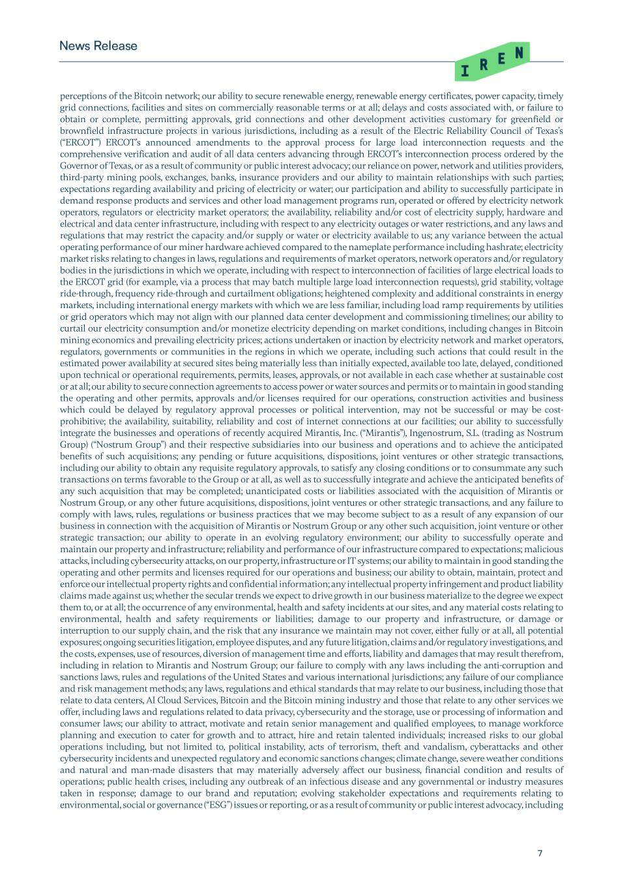
7 perceptions of the Bitcoin network; our ability to secure renewable energy, renewable energy certificates, power capacity, timely grid connections, facilities and sites on commercially reasonable terms or at all; delays and costs associated with, or failure to obtain or complete, permitting approvals, grid connections and other development activities customary for greenfield or brownfield infrastructure projects in various jurisdictions, including as a result of the Electric Reliability Council of Texas’s (“ERCOT”) ERCOT’s announced amendments to the approval process for large load interconnection requests and the comprehensive verification and audit of all data centers advancing through ERCOT’s interconnection process ordered by the Governor of Texas, or as a result of community or public interest advocacy; our reliance on power, network and utilities providers, third-party mining pools, exchanges, banks, insurance providers and our ability to maintain relationships with such parties; expectations regarding availability and pricing of electricity or water; our participation and ability to successfully participate in demand response products and services and other load management programs run, operated or offered by electricity network operators, regulators or electricity market operators; the availability, reliability and/or cost of electricity supply, hardware and electrical and data center infrastructure, including with respect to any electricity outages or water restrictions, and any laws and regulations that may restrict the capacity and/or supply or water or electricity available to us; any variance between the actual operating performance of our miner hardware achieved compared to the nameplate performance including hashrate; electricity market risks relating to changes in laws, regulations and requirements of market operators, network operators and/or regulatory bodies in the jurisdictions in which we operate, including with respect to interconnection of facilities of large electrical loads to the ERCOT grid (for example, via a process that may batch multiple large load interconnection requests), grid stability, voltage ride-through, frequency ride-through and curtailment obligations; heightened complexity and additional constraints in energy markets, including international energy markets with which we are less familiar, including load ramp requirements by utilities or grid operators which may not align with our planned data center development and commissioning timelines; our ability to curtail our electricity consumption and/or monetize electricity depending on market conditions, including changes in Bitcoin mining economics and prevailing electricity prices; actions undertaken or inaction by electricity network and market operators, regulators, governments or communities in the regions in which we operate, including such actions that could result in the estimated power availability at secured sites being materially less than initially expected, available too late, delayed, conditioned upon technical or operational requirements, permits, leases, approvals, or not available in each case whether at sustainable cost or at all; our ability to secure connection agreements to access power or water sources and permits or to maintain in good standing the operating and other permits, approvals and/or licenses required for our operations, construction activities and business which could be delayed by regulatory approval processes or political intervention, may not be successful or may be cost- prohibitive; the availability, suitability, reliability and cost of internet connections at our facilities; our ability to successfully integrate the businesses and operations of recently acquired Mirantis, Inc. (“Mirantis”), Ingenostrum, S.L. (trading as Nostrum Group) (“Nostrum Group”) and their respective subsidiaries into our business and operations and to achieve the anticipated benefits of such acquisitions; any pending or future acquisitions, dispositions, joint ventures or other strategic transactions, including our ability to obtain any requisite regulatory approvals, to satisfy any closing conditions or to consummate any such transactions on terms favorable to the Group or at all, as well as to successfully integrate and achieve the anticipated benefits of any such acquisition that may be completed; unanticipated costs or liabilities associated with the acquisition of Mirantis or Nostrum Group, or any other future acquisitions, dispositions, joint ventures or other strategic transactions, and any failure to comply with laws, rules, regulations or business practices that we may become subject to as a result of any expansion of our business in connection with the acquisition of Mirantis or Nostrum Group or any other such acquisition, joint venture or other strategic transaction; our ability to operate in an evolving regulatory environment; our ability to successfully operate and maintain our property and infrastructure; reliability and performance of our infrastructure compared to expectations; malicious attacks, including cybersecurity attacks, on our property, infrastructure or IT systems; our ability to maintain in good standing the operating and other permits and licenses required for our operations and business; our ability to obtain, maintain, protect and enforce our intellectual property rights and confidential information; any intellectual property infringement and product liability claims made against us; whether the secular trends we expect to drive growth in our business materialize to the degree we expect them to, or at all; the occurrence of any environmental, health and safety incidents at our sites, and any material costs relating to environmental, health and safety requirements or liabilities; damage to our property and infrastructure, or damage or interruption to our supply chain, and the risk that any insurance we maintain may not cover, either fully or at all, all potential exposures; ongoing securities litigation, employee disputes, and any future litigation, claims and/or regulatory investigations, and the costs, expenses, use of resources, diversion of management time and efforts, liability and damages that may result therefrom, including in relation to Mirantis and Nostrum Group; our failure to comply with any laws including the anti-corruption and sanctions laws, rules and regulations of the United States and various international jurisdictions; any failure of our compliance and risk management methods; any laws, regulations and ethical standards that may relate to our business, including those that relate to data centers, AI Cloud Services, Bitcoin and the Bitcoin mining industry and those that relate to any other services we offer, including laws and regulations related to data privacy, cybersecurity and the storage, use or processing of information and consumer laws; our ability to attract, motivate and retain senior management and qualified employees, to manage workforce planning and execution to cater for growth and to attract, hire and retain talented individuals; increased risks to our global operations including, but not limited to, political instability, acts of terrorism, theft and vandalism, cyberattacks and other cybersecurity incidents and unexpected regulatory and economic sanctions changes; climate change, severe weather conditions and natural and man-made disasters that may materially adversely affect our business, financial condition and results of operations; public health crises, including any outbreak of an infectious disease and any governmental or industry measures taken in response; damage to our brand and reputation; evolving stakeholder expectations and requirements relating to environmental, social or governance (“ESG”) issues or reporting, or as a result of community or public interest advocacy, including

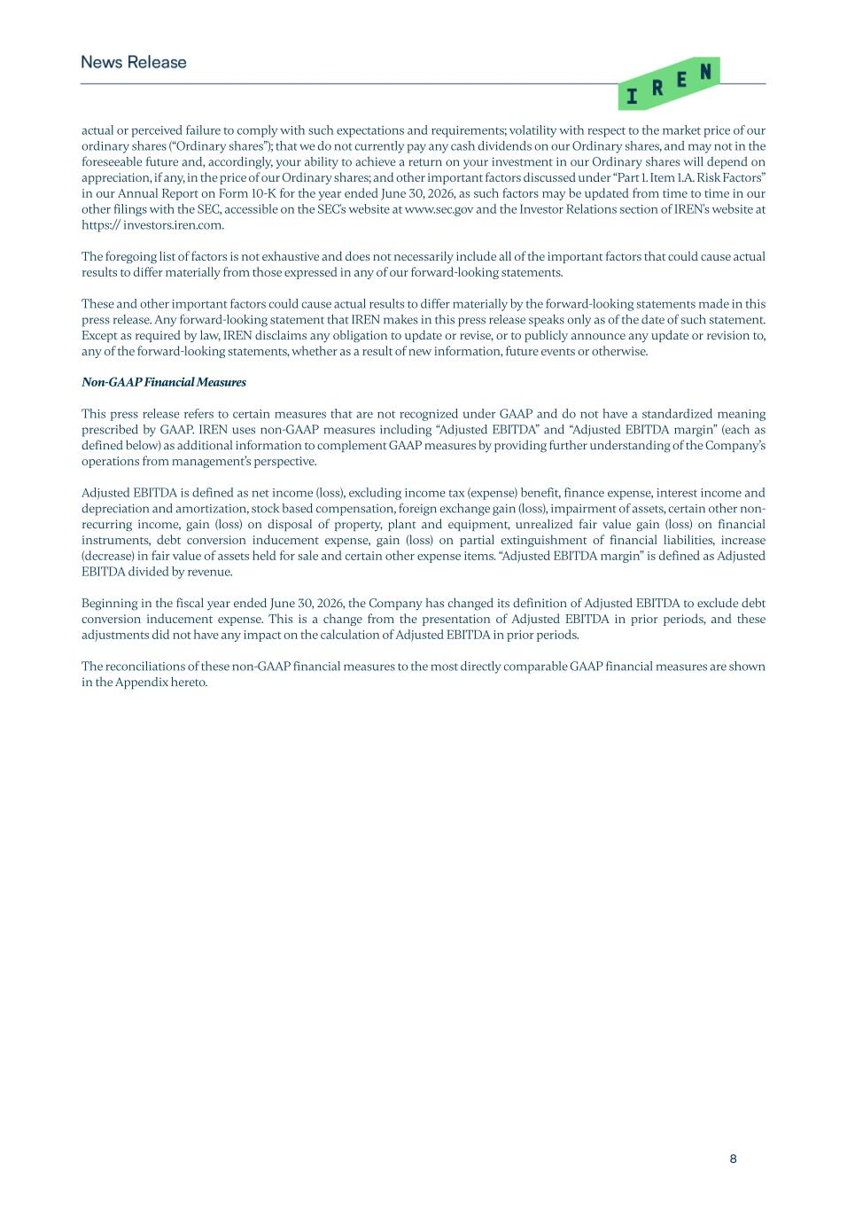
8 actual or perceived failure to comply with such expectations and requirements; volatility with respect to the market price of our ordinary shares (“Ordinary shares”); that we do not currently pay any cash dividends on our Ordinary shares, and may not in the foreseeable future and, accordingly, your ability to achieve a return on your investment in our Ordinary shares will depend on appreciation, if any, in the price of our Ordinary shares; and other important factors discussed under “Part 1. Item 1.A. Risk Factors” in our Annual Report on Form 10-K for the year ended June 30, 2026, as such factors may be updated from time to time in our other filings with the SEC, accessible on the SEC's website at www.sec.gov and the Investor Relations section of IREN's website at https:// investors.iren.com. The foregoing list of factors is not exhaustive and does not necessarily include all of the important factors that could cause actual results to differ materially from those expressed in any of our forward-looking statements. These and other important factors could cause actual results to differ materially by the forward-looking statements made in this press release. Any forward-looking statement that IREN makes in this press release speaks only as of the date of such statement. Except as required by law, IREN disclaims any obligation to update or revise, or to publicly announce any update or revision to, any of the forward-looking statements, whether as a result of new information, future events or otherwise. Non-GAAP Financial Measures This press release refers to certain measures that are not recognized under GAAP and do not have a standardized meaning prescribed by GAAP. IREN uses non-GAAP measures including “Adjusted EBITDA” and “Adjusted EBITDA margin” (each as defined below) as additional information to complement GAAP measures by providing further understanding of the Company’s operations from management’s perspective. Adjusted EBITDA is defined as net income (loss), excluding income tax (expense) benefit, finance expense, interest income and depreciation and amortization, stock based compensation, foreign exchange gain (loss), impairment of assets, certain other non- recurring income, gain (loss) on disposal of property, plant and equipment, unrealized fair value gain (loss) on financial instruments, debt conversion inducement expense, gain (loss) on partial extinguishment of financial liabilities, increase (decrease) in fair value of assets held for sale and certain other expense items. “Adjusted EBITDA margin” is defined as Adjusted EBITDA divided by revenue. Beginning in the fiscal year ended June 30, 2026, the Company has changed its definition of Adjusted EBITDA to exclude debt conversion inducement expense. This is a change from the presentation of Adjusted EBITDA in prior periods, and these adjustments did not have any impact on the calculation of Adjusted EBITDA in prior periods. The reconciliations of these non-GAAP financial measures to the most directly comparable GAAP financial measures are shown in the Appendix hereto.

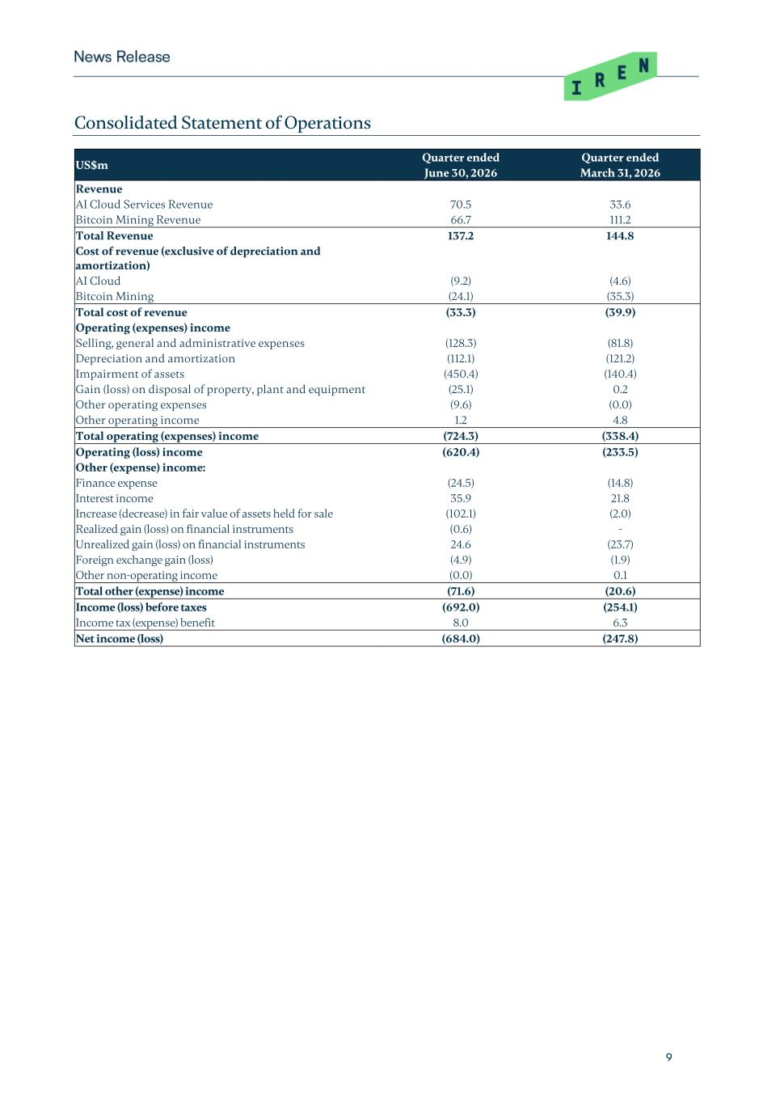
9 Consolidated Statement of Operations US$m Quarter ended Quarter ended June 30, 2026 March 31, 2026 Revenue AI Cloud Services Revenue 70.5 33.6 Bitcoin Mining Revenue 66.7 111.2 Total Revenue 137.2 144.8 Cost of revenue (exclusive of depreciation and amortization) AI Cloud (9.2) (4.6) Bitcoin Mining (24.1) (35.3) Total cost of revenue (33.3) (39.9) Operating (expenses) income Selling, general and administrative expenses (128.3) (81.8) Depreciation and amortization (112.1) (121.2) Impairment of assets (450.4) (140.4) Gain (loss) on disposal of property, plant and equipment (25.1) 0.2 Other operating expenses (9.6) (0.0) Other operating income 1.2 4.8 Total operating (expenses) income (724.3) (338.4) Operating (loss) income (620.4) (233.5) Other (expense) income: Finance expense (24.5) (14.8) Interest income 35.9 21.8 Increase (decrease) in fair value of assets held for sale (102.1) (2.0) Realized gain (loss) on financial instruments (0.6) - Unrealized gain (loss) on financial instruments 24.6 (23.7) Foreign exchange gain (loss) (4.9) (1.9) Other non-operating income (0.0) 0.1 Total other (expense) income (71.6) (20.6) Income (loss) before taxes (692.0) (254.1) Income tax (expense) benefit 8.0 6.3 Net income (loss) (684.0) (247.8)

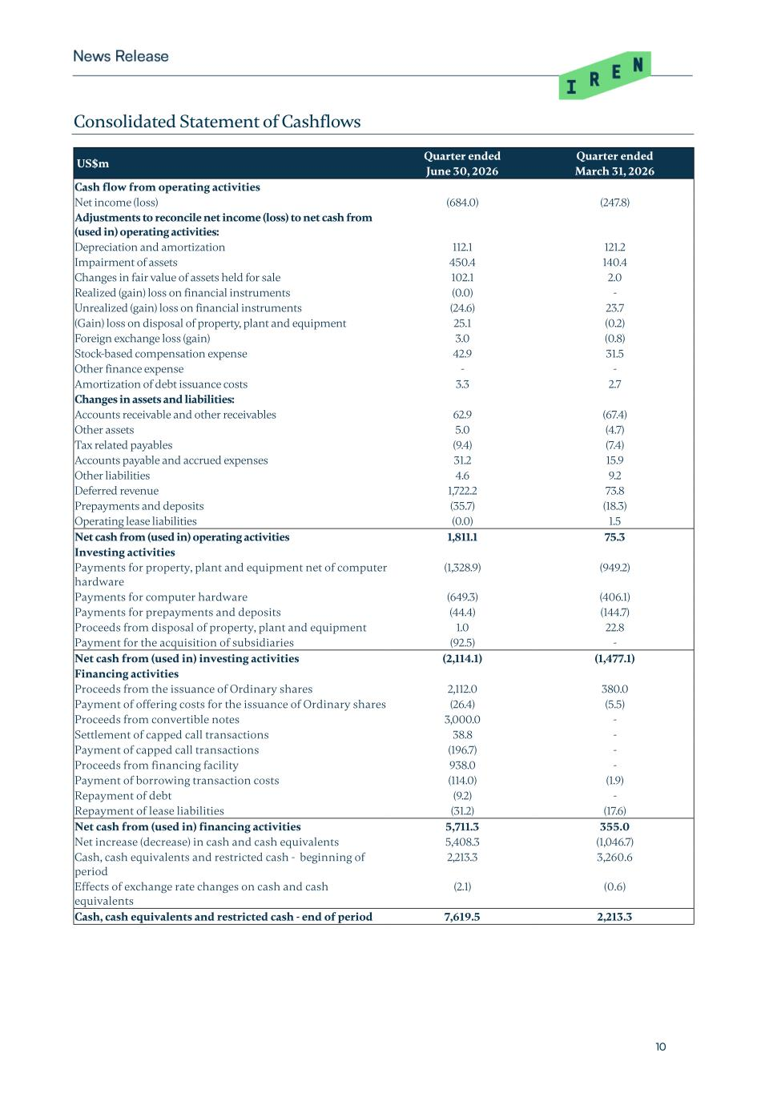
10 Consolidated Statement of Cashflows US$m Quarter ended Quarter ended June 30, 2026 March 31, 2026 Cash flow from operating activities Net income (loss) (684.0) (247.8) Adjustments to reconcile net income (loss) to net cash from (used in) operating activities: Depreciation and amortization 112.1 121.2 Impairment of assets 450.4 140.4 Changes in fair value of assets held for sale 102.1 2.0 Realized (gain) loss on financial instruments (0.0) - Unrealized (gain) loss on financial instruments (24.6) 23.7 (Gain) loss on disposal of property, plant and equipment 25.1 (0.2) Foreign exchange loss (gain) 3.0 (0.8) Stock-based compensation expense 42.9 31.5 Other finance expense - - Amortization of debt issuance costs 3.3 2.7 Changes in assets and liabilities: Accounts receivable and other receivables 62.9 (67.4) Other assets 5.0 (4.7) Tax related payables (9.4) (7.4) Accounts payable and accrued expenses 31.2 15.9 Other liabilities 4.6 9.2 Deferred revenue 1,722.2 73.8 Prepayments and deposits (35.7) (18.3) Operating lease liabilities (0.0) 1.5 Net cash from (used in) operating activities 1,811.1 75.3 Investing activities Payments for property, plant and equipment net of computer hardware (1,328.9) (949.2) Payments for computer hardware (649.3) (406.1) Payments for prepayments and deposits (44.4) (144.7) Proceeds from disposal of property, plant and equipment 1.0 22.8 Payment for the acquisition of subsidiaries (92.5) - Net cash from (used in) investing activities (2,114.1) (1,477.1) Financing activities Proceeds from the issuance of Ordinary shares 2,112.0 380.0 Payment of offering costs for the issuance of Ordinary shares (26.4) (5.5) Proceeds from convertible notes 3,000.0 - Settlement of capped call transactions 38.8 - Payment of capped call transactions (196.7) - Proceeds from financing facility 938.0 - Payment of borrowing transaction costs (114.0) (1.9) Repayment of debt (9.2) - Repayment of lease liabilities (31.2) (17.6) Net cash from (used in) financing activities 5,711.3 355.0 Net increase (decrease) in cash and cash equivalents 5,408.3 (1,046.7) Cash, cash equivalents and restricted cash - beginning of period 2,213.3 3,260.6 Effects of exchange rate changes on cash and cash equivalents (2.1) (0.6) Cash, cash equivalents and restricted cash - end of period 7,619.5 2,213.3

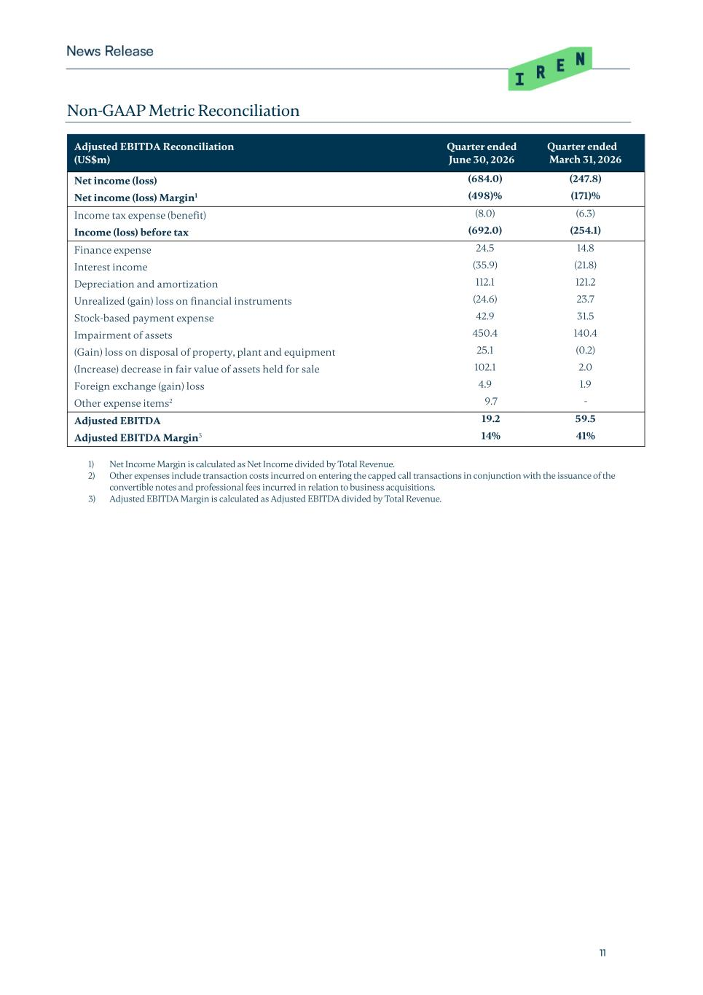
11 Non-GAAP Metric Reconciliation Adjusted EBITDA Reconciliation (US$m) Quarter ended June 30, 2026 Quarter ended March 31, 2026 Net income (loss) (684.0) (247.8) Net income (loss) Margin1 (498)% (171)% Income tax expense (benefit) (8.0) (6.3) Income (loss) before tax (692.0) (254.1) Finance expense 24.5 14.8 Interest income (35.9) (21.8) Depreciation and amortization 112.1 121.2 Unrealized (gain) loss on financial instruments (24.6) 23.7 Stock-based payment expense 42.9 31.5 Impairment of assets 450.4 140.4 (Gain) loss on disposal of property, plant and equipment 25.1 (0.2) (Increase) decrease in fair value of assets held for sale 102.1 2.0 Foreign exchange (gain) loss 4.9 1.9 Other expense items2 9.7 - Adjusted EBITDA 19.2 59.5 Adjusted EBITDA Margin3 14% 41% 1) Net Income Margin is calculated as Net Income divided by Total Revenue. 2) Other expenses include transaction costs incurred on entering the capped call transactions in conjunction with the issuance of the convertible notes and professional fees incurred in relation to business acquisitions. 3) Adjusted EBITDA Margin is calculated as Adjusted EBITDA divided by Total Revenue.

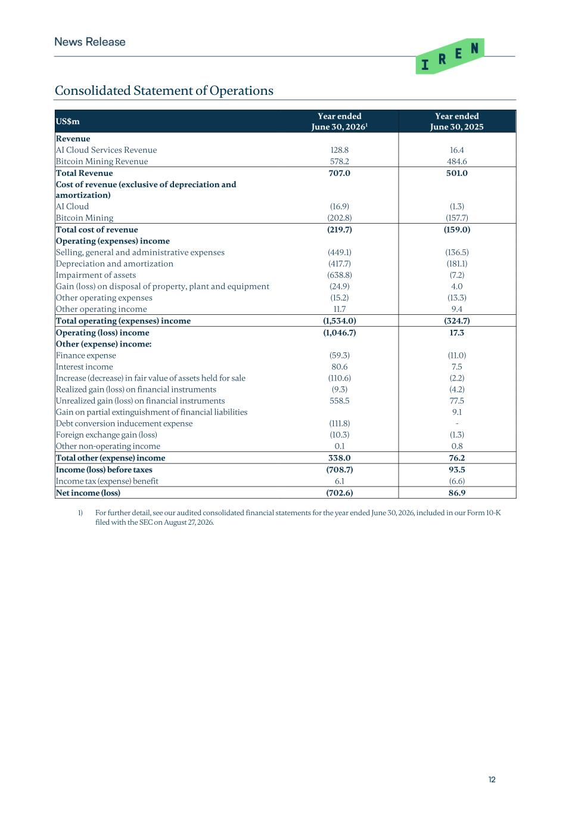
12 Consolidated Statement of Operations US$m Year ended Year ended June 30, 20261 June 30, 2025 Revenue AI Cloud Services Revenue 128.8 16.4 Bitcoin Mining Revenue 578.2 484.6 Total Revenue 707.0 501.0 Cost of revenue (exclusive of depreciation and amortization) AI Cloud (16.9) (1.3) Bitcoin Mining (202.8) (157.7) Total cost of revenue (219.7) (159.0) Operating (expenses) income Selling, general and administrative expenses (449.1) (136.5) Depreciation and amortization (417.7) (181.1) Impairment of assets (638.8) (7.2) Gain (loss) on disposal of property, plant and equipment (24.9) 4.0 Other operating expenses (15.2) (13.3) Other operating income 11.7 9.4 Total operating (expenses) income (1,534.0) (324.7) Operating (loss) income (1,046.7) 17.3 Other (expense) income: Finance expense (59.3) (11.0) Interest income 80.6 7.5 Increase (decrease) in fair value of assets held for sale (110.6) (2.2) Realized gain (loss) on financial instruments (9.3) (4.2) Unrealized gain (loss) on financial instruments 558.5 77.5 Gain on partial extinguishment of financial liabilities 9.1 Debt conversion inducement expense (111.8) - Foreign exchange gain (loss) (10.3) (1.3) Other non-operating income 0.1 0.8 Total other (expense) income 338.0 76.2 Income (loss) before taxes (708.7) 93.5 Income tax (expense) benefit 6.1 (6.6) Net income (loss) (702.6) 86.9 1) For further detail, see our audited consolidated financial statements for the year ended June 30, 2026, included in our Form 10-K filed with the SEC on August 27, 2026.

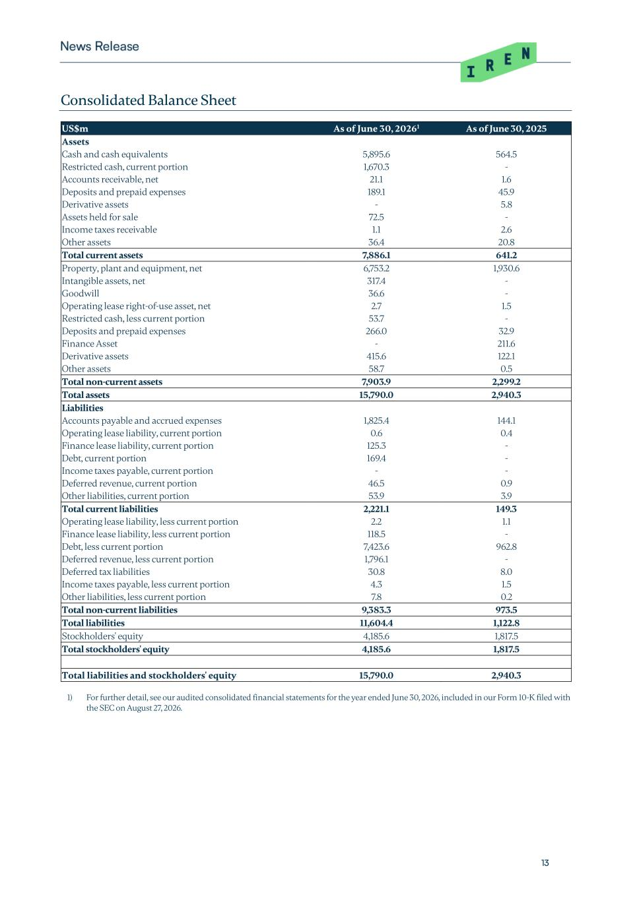
13 Consolidated Balance Sheet US$m As of June 30, 20261 As of June 30, 2025 Assets Cash and cash equivalents 5,895.6 564.5 Restricted cash, current portion 1,670.3 - Accounts receivable, net 21.1 1.6 Deposits and prepaid expenses 189.1 45.9 Derivative assets - 5.8 Assets held for sale 72.5 - Income taxes receivable 1.1 2.6 Other assets 36.4 20.8 Total current assets 7,886.1 641.2 Property, plant and equipment, net 6,753.2 1,930.6 Intangible assets, net 317.4 - Goodwill 36.6 - Operating lease right-of-use asset, net 2.7 1.5 Restricted cash, less current portion 53.7 - Deposits and prepaid expenses 266.0 32.9 Finance Asset - 211.6 Derivative assets 415.6 122.1 Other assets 58.7 0.5 Total non-current assets 7,903.9 2,299.2 Total assets 15,790.0 2,940.3 Liabilities Accounts payable and accrued expenses 1,825.4 144.1 Operating lease liability, current portion 0.6 0.4 Finance lease liability, current portion 125.3 - Debt, current portion 169.4 - Income taxes payable, current portion - - Deferred revenue, current portion 46.5 0.9 Other liabilities, current portion 53.9 3.9 Total current liabilities 2,221.1 149.3 Operating lease liability, less current portion 2.2 1.1 Finance lease liability, less current portion 118.5 - Debt, less current portion 7,423.6 962.8 Deferred revenue, less current portion 1,796.1 - Deferred tax liabilities 30.8 8.0 Income taxes payable, less current portion 4.3 1.5 Other liabilities, less current portion 7.8 0.2 Total non-current liabilities 9,383.3 973.5 Total liabilities 11,604.4 1,122.8 Stockholders' equity 4,185.6 1,817.5 Total stockholders' equity 4,185.6 1,817.5 Total liabilities and stockholders' equity 15,790.0 2,940.3 1) For further detail, see our audited consolidated financial statements for the year ended June 30, 2026, included in our Form 10-K filed with the SEC on August 27, 2026.

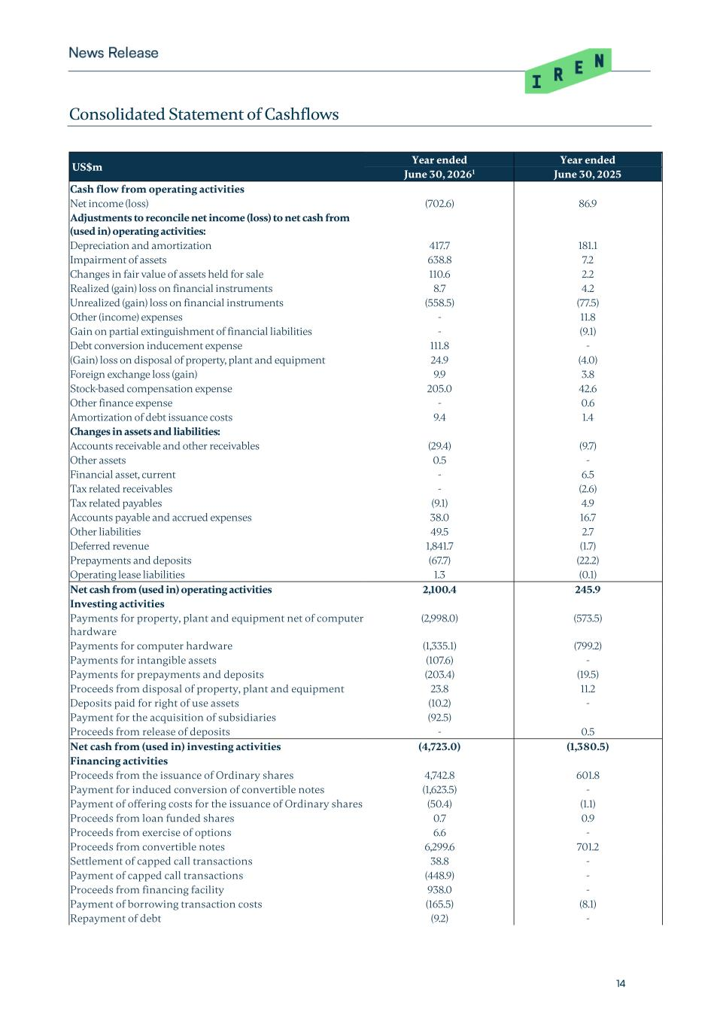
14 Consolidated Statement of Cashflows US$m Year ended Year ended June 30, 20261 June 30, 2025 Cash flow from operating activities Net income (loss) (702.6) 86.9 Adjustments to reconcile net income (loss) to net cash from (used in) operating activities: Depreciation and amortization 417.7 181.1 Impairment of assets 638.8 7.2 Changes in fair value of assets held for sale 110.6 2.2 Realized (gain) loss on financial instruments 8.7 4.2 Unrealized (gain) loss on financial instruments (558.5) (77.5) Other (income) expenses - 11.8 Gain on partial extinguishment of financial liabilities - (9.1) Debt conversion inducement expense 111.8 - (Gain) loss on disposal of property, plant and equipment 24.9 (4.0) Foreign exchange loss (gain) 9.9 3.8 Stock-based compensation expense 205.0 42.6 Other finance expense - 0.6 Amortization of debt issuance costs 9.4 1.4 Changes in assets and liabilities: Accounts receivable and other receivables (29.4) (9.7) Other assets 0.5 - Financial asset, current - 6.5 Tax related receivables - (2.6) Tax related payables (9.1) 4.9 Accounts payable and accrued expenses 38.0 16.7 Other liabilities 49.5 2.7 Deferred revenue 1,841.7 (1.7) Prepayments and deposits (67.7) (22.2) Operating lease liabilities 1.3 (0.1) Net cash from (used in) operating activities 2,100.4 245.9 Investing activities Payments for property, plant and equipment net of computer hardware (2,998.0) (573.5) Payments for computer hardware (1,335.1) (799.2) Payments for intangible assets (107.6) - Payments for prepayments and deposits (203.4) (19.5) Proceeds from disposal of property, plant and equipment 23.8 11.2 Deposits paid for right of use assets (10.2) - Payment for the acquisition of subsidiaries (92.5) Proceeds from release of deposits - 0.5 Net cash from (used in) investing activities (4,723.0) (1,380.5) Financing activities Proceeds from the issuance of Ordinary shares 4,742.8 601.8 Payment for induced conversion of convertible notes (1,623.5) - Payment of offering costs for the issuance of Ordinary shares (50.4) (1.1) Proceeds from loan funded shares 0.7 0.9 Proceeds from exercise of options 6.6 - Proceeds from convertible notes 6,299.6 701.2 Settlement of capped call transactions 38.8 - Payment of capped call transactions (448.9) - Proceeds from financing facility 938.0 - Payment of borrowing transaction costs (165.5) (8.1) Repayment of debt (9.2) -

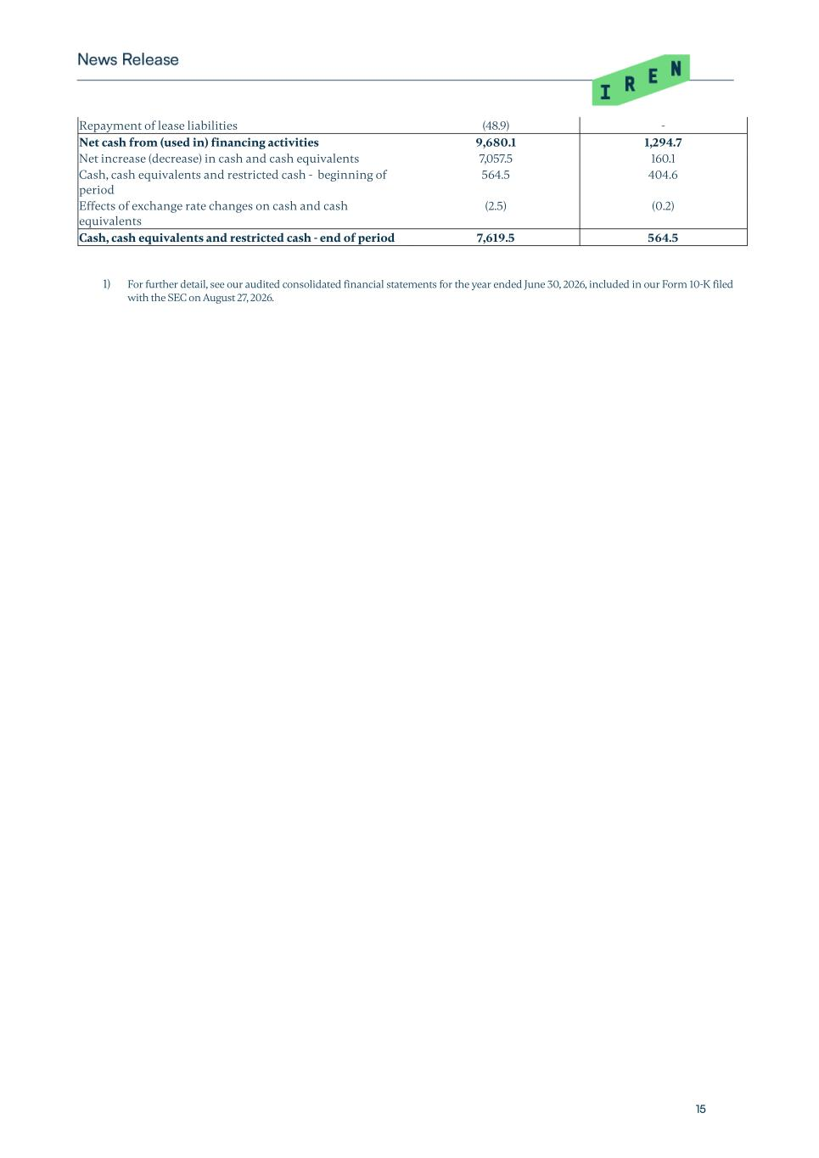
15 Repayment of lease liabilities (48.9) - Net cash from (used in) financing activities 9,680.1 1,294.7 Net increase (decrease) in cash and cash equivalents 7,057.5 160.1 Cash, cash equivalents and restricted cash - beginning of period 564.5 404.6 Effects of exchange rate changes on cash and cash equivalents (2.5) (0.2) Cash, cash equivalents and restricted cash - end of period 7,619.5 564.5 1) For further detail, see our audited consolidated financial statements for the year ended June 30, 2026, included in our Form 10-K filed with the SEC on August 27, 2026.

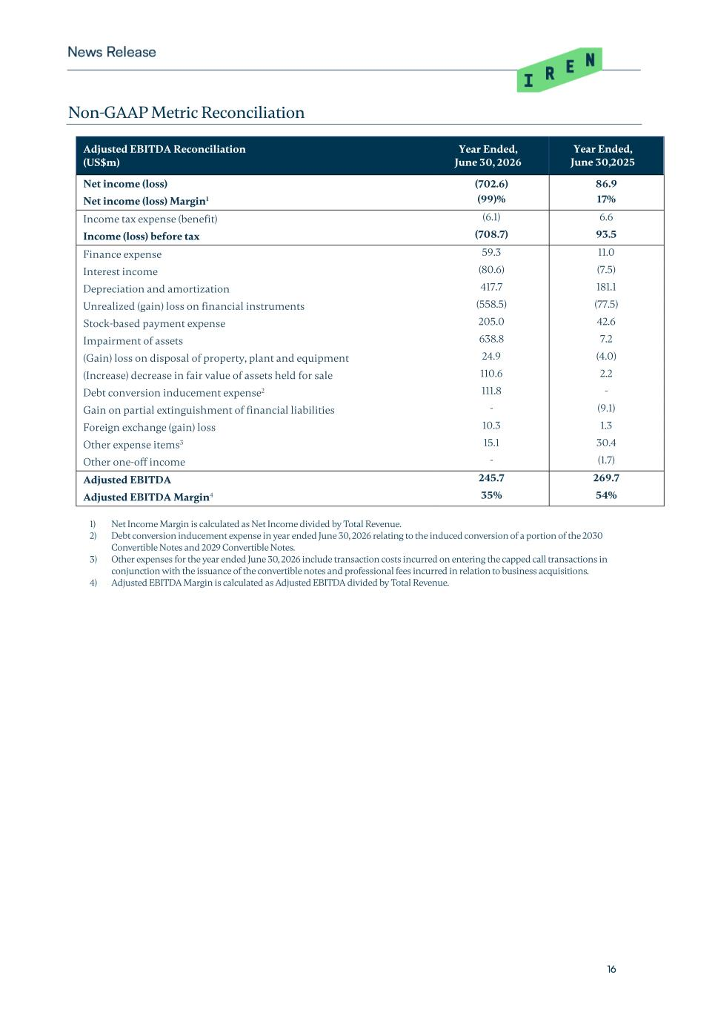
16 Non-GAAP Metric Reconciliation Adjusted EBITDA Reconciliation (US$m) Year Ended, June 30, 2026 Year Ended, June 30,2025 Net income (loss) (702.6) 86.9 Net income (loss) Margin1 (99)% 17% Income tax expense (benefit) (6.1) 6.6 Income (loss) before tax (708.7) 93.5 Finance expense 59.3 11.0 Interest income (80.6) (7.5) Depreciation and amortization 417.7 181.1 Unrealized (gain) loss on financial instruments (558.5) (77.5) Stock-based payment expense 205.0 42.6 Impairment of assets 638.8 7.2 (Gain) loss on disposal of property, plant and equipment 24.9 (4.0) (Increase) decrease in fair value of assets held for sale 110.6 2.2 Debt conversion inducement expense2 111.8 - Gain on partial extinguishment of financial liabilities - (9.1) Foreign exchange (gain) loss 10.3 1.3 Other expense items3 15.1 30.4 Other one-off income - (1.7) Adjusted EBITDA 245.7 269.7 Adjusted EBITDA Margin4 35% 54% 1) Net Income Margin is calculated as Net Income divided by Total Revenue. 2) Debt conversion inducement expense in year ended June 30, 2026 relating to the induced conversion of a portion of the 2030 Convertible Notes and 2029 Convertible Notes. 3) Other expenses for the year ended June 30, 2026 include transaction costs incurred on entering the capped call transactions in conjunction with the issuance of the convertible notes and professional fees incurred in relation to business acquisitions. 4) Adjusted EBITDA Margin is calculated as Adjusted EBITDA divided by Total Revenue.

