UNITED STATES

SECURITIES AND EXCHANGE COMMISSION

Washington, D.C. 20549

FORM 6-K

REPORT OF FOREIGN PRIVATE ISSUER

PURSUANT TO SECTION 13A-16 OR 15D-16

UNDER THE SECURITIES EXCHANGE ACT OF 1934

For the month of April 2024

Commission File Number: 001-41072

Iris Energy Limited

(Translation of registrant’s name into English)

Level 12, 44 Market Street

Sydney, NSW 2000 Australia

+61 2 7906 8301

(Address of principal executive office)

Indicate by check mark whether the registrant files or will file annual reports under cover of Form 20-F or Form 40-F.

Form 20-F ☒ Form 40-F ☐

Indicate by check mark if the registrant is submitting the Form 6-K in paper as permitted by Regulation S-T Rule 101(b)(1): ☐

Indicate by check mark if the registrant is submitting the Form 6-K in paper as permitted by Regulation S-T Rule 101(b)(7): ☐

EXPLANATORY NOTE

On April 4, 2024, Iris Energy Limited (dba IREN) (the “Company”) released a monthly investor update regarding its results of operations for March 2024 and provided a business update. A copy of the Company’s investor update is furnished hereto as Exhibit 99.1.

 |  |  | EXHIBIT INDEX
Exhibit
 | No. |  | Description
99.1 |  |  | Iris Energy Limited (dba IREN), March 2024 Monthly Investor Update, dated April 4, 2024

SIGNATURES

Pursuant to the requirements of the Securities Exchange Act of 1934, as amended, the registrant has duly caused this report to be signed on its behalf by the undersigned hereunto duly authorized.

Iris Energy Limited

Date: April 4, 2024 By: /s/ Daniel Roberts

Daniel Roberts

Co-Chief Executive Officer and Director

Exhibit 99.1
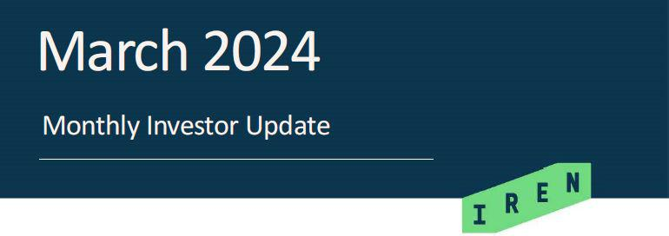

SYDNEY, Australia, April 4, 2024 (GLOBE NEWSWIRE) -- IREN (NASDAQ: IREN) (together with its subsidiaries, “IREN” or “the Company”), a leading next-generation data center business powering the future of Bitcoin, AI and beyond, today published a monthly investor update for March 2024.

Key Highlights

Bitcoin Mining |  | AI Cloud Services
• 353 Bitcoin mined in March |  | • | NVIDIA H100 GPUs
• | 8 EH/s operating, 20 EH/s in 2024 |  | o | 248 operating
• | Expansion fully funded |  | o | 568 commissioning
 |  | • | Customer negotiations in progress



Data Centers |  | Corporate
• | 220MW operating, 460MW in 2024 | • $301m cash, no debt
• | New and optimized data center design expediting | • | 2024 expansion fully funded
 | construction timelines | • | Quarterly reporting to start from March 31, 2024



Key Metrics

Bitcoin Mining¹ |  | Feb-24 | Jan-24
Bitcoin Mining¹ | Mar-24 | Feb-24 | Jan-24
Average operating hashrate (PH/s) | 7,107 | 6,299 | 5,642
Renewable energy usage (MW)² | 195 | 174 | 163
Bitcoin mined | 353 | 310 | 341
Mining revenue (US$’000) | 23,705 | 15,212 | 14,466
Electricity costs (US$’000)³ | 7,172 | 6,241 | 6,376
Revenue per Bitcoin (US$) | 67,235 | 49,134 | 42,436
Electricity cost per Bitcoin (US$) | 20,343 | 20,158 | 18,705

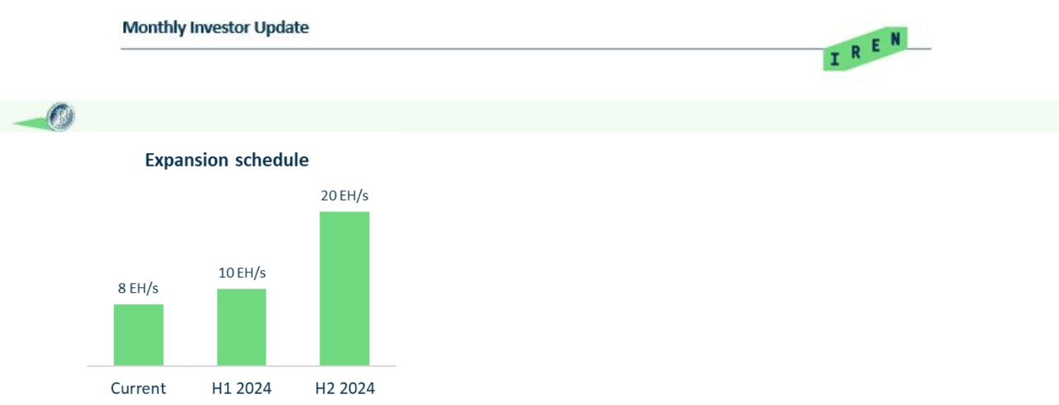
Bitcoin Mining

March operations

- Average operating hashrate of 7.1 EH/s (now expanded to 8 EH/s)
- Monthly mining revenue increased by 56% to $23.7m, due to increased hashrate and higher Bitcoin price

2024 expansion to 20 EH/s, now fully funded

- H1 2024 (10 EH/s) – 8 EH/s operating, remaining 2 EH/s to be commissioned
- H2 2024 (20 EH/s) – 10 EH/s of new miners secured⁴
- 20 EH/s generates ~$269m of annualized hardware profit (post-halving)⁵

AI Cloud Services

AI Cloud Services
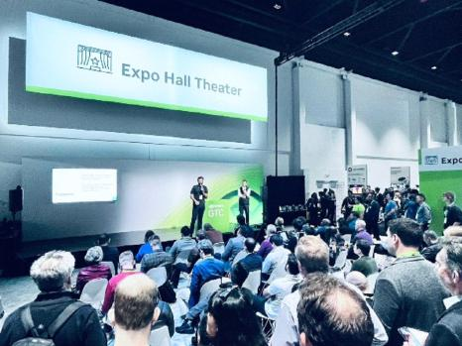
- Recently presented at NVIDIA GTC, with poolsideAI’s Co-Founder & CTO joining the stage to highlight the strength of IREN’s cloud services capabilities

- NVIDIA H100 GPUs:

o Located at our Prince George data center o 248 GPUs operating
o 568 GPUs undergoing commissioning

- Customer negotiations for new capacity in progress

- 816 GPUs generates an estimated ~$14-$17m of annualized hardware profit (~24 month payback)⁵

poolsideAI’s CTO & Co-Founder presenting alongside

IREN CEO & Co-Founder at NVIDIA GTC

Data Centers
460MW of data centers
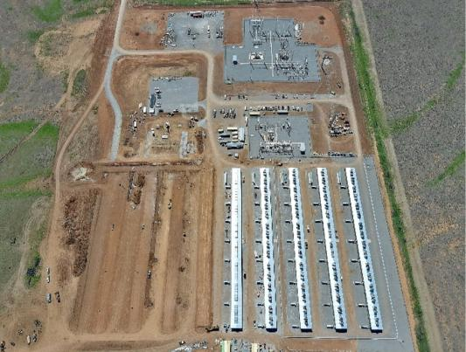
- Childress Phase 1 (first 100MW) – H1 2024

o Supports expansion to 10 EH/s

o 60MW operating, 40MW under construction

- Childress Phase 2 & 3 (next 200MW) – H2 2024

o Supports expansion to 20 EH/s

o Construction underway with ~180 personnel on site

o New and optimized data center design expediting construction timelines through increased power density per building and constructability improvements

Childress (March 29, 2024)

2

Data Center | Capacity | Capacity | Timing | Status
Data Center | (MW) | (EH/s)⁴ | Timing | Status
Canal Flats (BC, Canada) | 30 | 0.9 | Complete | Operating
Mackenzie (BC, Canada) | 80 | 2.8 | Complete | Operating
Prince George (BC, Canada) | 50 | 1.6 | Complete | Operating
Childress Phase 1 (Texas, USA) | 60 | 2.7 | Complete | Operating
Total Operating | 220 | 8.0
Childress Phase 1 (Texas, USA) | 40 | 2.0 | H1 2024 | Under construction
Childress Phase 2-3 (Texas USA) | 200 | 10.0 | H2 2024 | Under construction
Total Operating & Construction | 460 | 20.0
Childress Phase 4-6 (Texas, USA) | 300 |  | TBD | Power available
Development Site (Texas, USA) | 1,400 |  | Late 2026 | Connection underway
Total Capacity | 2,160

Corporate

Funding & corporate
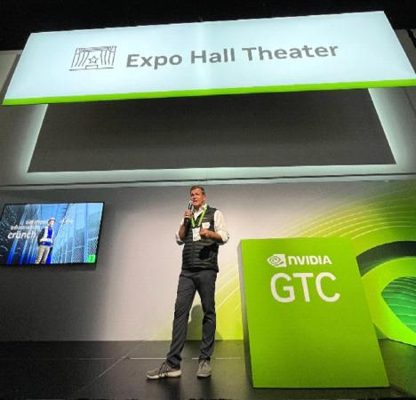
- $301m cash⁶, no debt

- Expansion to 460MW of data centers and 20 EH/s of Bitcoin mining in 2024 now fully funded, following completion of a targeted ATM equity raising program

- Quarterly reporting to commence from the quarter ending March 31, 2024

Upcoming events

- CG Digital Assets Symposium (April 11, 2024)

- London non-deal roadshow (April 8 - 11, 2024)

- CheatCode UK (April 12 - 13, 2024)

IREN Co-Founder & Co-CEO Daniel Roberts

presenting at NVIDIA GTC

3

Contacts


Media | Investors
Jon Snowball | Lincoln Tan
Domestique | IREN
+61 477 946 068 | +61 407 423 395
Danielle Ghigliera | lincoln.tan@iren.com
Aircover Communications
+1 510 333 2707

To keep updated on IREN’s news releases and SEC filings, please subscribe to email alerts at https://iren.com/investor/ir-resources/email-alerts.

Forward-Looking Statements

This investor update includes “forward-looking statements” within the meaning of the Private Securities Litigation Reform Act of 1995. Forward-looking statements generally relate to future events or IREN’s future financial or operating performance. For example, forward-looking statements include but are not limited to the Company’s business strategy, expected operational and financial results, and expected increase in power capacity and hashrate. In some cases, you can identify forward-looking statements by terminology such as “anticipate,” “believe,” “may,” “can,” “should,” “could,” “might,” “plan,” “possible,” “project,” “strive,” “budget,” “forecast,” “expect,” “intend,” “target”, “will,” “estimate,” “predict,” “potential,” “continue,” “scheduled” or the negatives of these terms or variations of them or similar terminology, but the absence of these words does not mean that statement is not forward-looking. Such forward-looking statements are subject to risks, uncertainties, and other factors which could cause actual results to differ materially from those expressed or implied by such forward-looking statements. In addition, any statements or information that refer to expectations, beliefs, plans, projections, objectives, performance or other characterizations of future events or circumstances, including any underlying assumptions, are forward-looking.

4

These forward-looking statements are based on management’s current expectations and beliefs. These statements are neither promises nor guarantees, but involve known and unknown risks, uncertainties and other important factors that may cause IREN’s actual results, performance or achievements to be materially different from any future results performance or achievements expressed or implied by the forward looking statements, including, but not limited to: Bitcoin price and foreign currency exchange rate fluctuations; IREN’s ability to obtain additional capital on commercially reasonable terms and in a timely manner to meet its capital needs and facilitate its expansion plans; the terms of any future financing or any refinancing, restructuring or modification to the terms of any future financing, which could require IREN to comply with onerous covenants or restrictions, and its ability to service its debt obligations; IREN’s ability to successfully execute on its growth strategies and operating plans, including its ability to continue to develop its existing data center sites and its ability to diversify into the market for High Performance Computing (“HPC”) solutions; IREN’s limited experience with respect to new markets it has entered or may seek to enter, including the market for HPC solutions; expectations with respect to the ongoing profitability, viability, operability, security, popularity and public perceptions of the Bitcoin network; expectations with respect to the profitability, viability, operability, security, popularity and public perceptions of any HPC solutions that IREN offers; IREN’s ability to secure and retain customers on commercially reasonable terms or at all, particularly as it relates to its strategy to expand into HPC solutions; IREN’s ability to manage counterparty risk (including credit risk) associated with any current or future customers and other counterparties; IREN’s ability to secure renewable energy, renewable energy certificates, power capacity, facilities and sites on commercially reasonable terms or at all; the risk that any current or future customers or counterparties may terminate, default on or underperform their contractual obligations; Bitcoin global hashrate fluctuations; delays associated with, or failure to obtain or complete, permitting approvals, grid connections and other development activities customary for greenfield or brownfield infrastructure projects; our reliance on power utilities providers, third party mining pools, exchanges, banks, insurance providers and our ability to maintain relationships with such parties; expectations regarding availability and pricing of electricity; IREN’s participation and ability to successfully participate in demand response products and services and other load management programs run, operated or offered by electricity network operators, regulators or electricity market operators; the availability, reliability and/or cost of electricity supply, hardware and electrical and data center infrastructure, including with respect to any electricity outages and any laws and regulations that may restrict the electricity supply available to IREN; any variance between the actual operating performance of IREN’s hardware achieved compared to the nameplate performance including hashrate; IREN’s ability to curtail its electricity consumption and/or monetize electricity depending on market conditions, including changes in Bitcoin mining economics and prevailing electricity prices; actions undertaken by electricity network and market operators, regulators, governments or communities in the regions in which IREN operates; the availability, suitability, reliability and cost of internet connections at IREN’s facilities; IREN’s ability to secure additional hardware, including hardware for Bitcoin mining and HPC solutions it may offer, on commercially reasonable terms or at all, and any delays or reductions in the supply of such hardware or increases in the cost of procuring such hardware; expectations with respect to the useful life and obsolescence of hardware (including hardware for Bitcoin mining as well as hardware for other applications, including HPC solutions IREN may offer); delays, increases in costs or reductions in the supply of equipment used in IREN’s operations; IREN’s ability to operate in an evolving regulatory environment; IREN’s ability to successfully operate and maintain its property and infrastructure; reliability and performance of IREN’s infrastructure compared to expectations; malicious attacks on IREN’s property, infrastructure or IT systems; IREN’s ability to maintain in good standing the operating and other permits and licenses required for its operations and business; IREN ability to obtain, maintain, protect and enforce its intellectual property rights and other confidential information; whether the secular trends IREN expects to drive growth in its business materialize to the degree it expects them to, or at all; the occurrence of any environmental, health and safety incidents at IREN’s sites, and any material costs relating to environmental, health and safety requirements or liabilities; damage to our property and infrastructure and the risk that any insurance IREN maintains may not fully cover all potential exposures; ongoing proceedings relating to the default by two of IREN’s wholly-owned special purpose vehicles under limited recourse equipment financing facilities; ongoing securities litigation relating in part to the default; and any future litigation, claims and/or regulatory investigations, and the costs, expenses, use of resources, diversion of management time and efforts, liability and damages that may result therefrom; IREN’s failure to comply with any laws including the anti-corruption laws of the United States and various international jurisdictions; any failure of IREN’s compliance and risk management methods; any laws, regulations and ethical standards that may relate to IREN’s business, including those that relate to Bitcoin and the Bitcoin mining industry and those that relate to any other solutions we may offer (such as HPC solutions), including regulations related to data privacy, cybersecurity and the storage, use or processing of information; any intellectual property infringement and product liability claims; our ability to attract, motivate and retain senior management and qualified employees; increased risks to our global operations including, but not limited to, political instability, acts of terrorism, theft and vandalism, cyberattacks and other cybersecurity incidents and unexpected regulatory and economic sanctions changes, among other things; climate change, severe weather conditions and natural and man-made disasters that may materially adversely affect our business, financial condition and results of operations; the ongoing effects of COVID-19 or any other outbreak of an infectious disease and any governmental or industry measures taken in response; our ability to remain competitive in dynamic and rapidly evolving industries; damage to our brand and reputation; expectations relating to Environmental, Social and Governance issues or reporting; the costs of being a public company; and other important factors discussed under the caption “Risk Factors” in IREN’s annual report on Form 20-F filed with the SEC on September 13, 2023 as such factors may be updated from time to time in its other filings with the SEC, accessible on the SEC’s website at www.sec.gov and the Investor Relations section of IREN’s website at https://investors.iren.com.

These and other important factors could cause actual results to differ materially from those indicated by the forward-looking statements made in this investor update. Any forward-looking statement that IREN makes in this investor update speaks only as of the date of such statement. Except as required by law, IREN disclaims any obligation to update or revise, or to publicly announce any update or revision to, any of the forward-looking statements, whether as a result of new information, future events or otherwise.

Preliminary Financial Information

The preliminary financial information for the month of March 2024 included in this investor update is not subject to the same closing procedures as our unaudited quarterly financial results and has not been reviewed by our independent registered public accounting firm. The preliminary financial information included in this investor update does not represent a comprehensive statement of our financial results or financial position and should not be viewed as a substitute for unaudited financial statements prepared in accordance with International Financial Reporting Standards. Accordingly, you should not place undue reliance on the preliminary financial information included in this investor update.

- Bitcoin and Bitcoin mined in this investor update are presented in accordance with our revenue recognition policy which is determined on a Bitcoin received basis (post deduction of mining pool fees as applicable).

- Comprises actual power usage for Canal Flats, Mackenzie, Prince George, and Childress. The Company’s Canal Flats, Mackenzie and Prince George sites have been powered by 100% renewable energy since inception of which approximately 98% is directly from renewable energy sources; approximately 2% is from the purchase of RECs. The Company’s Childress site has been powered by 100% renewable energy since inception via the purchase of RECs.

5

- Represents electricity costs net of realized gain on financial asset. Realized gain on financial asset represents unaudited power credits (primarily driven by voluntary curtailment) earned under hedge contracts. February and March 2024 electricity cost includes net revenue generated from participation in ERCOT demand response program. Figures are based on current internal estimates and exclude REC purchases.
- Additional capacity to be installed comprises Bitmain T21 miner purchases of 3 EH/s and miner purchase options of 9 EH/s. Final decisions with respect to exercising miner purchase options will be made during 2024 taking into consideration market conditions.
- Illustrative Annualized Hardware Profit = revenue less assumed electricity costs (excludes all other site, overhead and REC costs). Bitcoin mining calculations assume hardware operates at 100% uptime and $0.04/kWh electricity costs. Source: Coinwarz Bitcoin Mining Calculator. Inputs: 20,000 PH/s (hashrate), ~595 EH/s (global hashrate), $70,000 (BTC price), 3.125 BTC (block reward), 0.3 BTC (transaction fees), 0.2% (pool fees), 440MW (power consumption). These inputs and assumptions are based on current and historical market conditions which may be different in the future. GPU calculations assume 1.25kW power draw required for 1 GPU, $0.05/kWh electricity costs and $2.00-2.50 per GPU hour revenue assumption. Hardware capex assumes ~$40k per GPU.

- Cash of $301m reflects USD equivalent, unaudited preliminary cash, cash equivalents and term deposits as of March 29, 2024 plus ATM proceeds to be received first week of April 2024 from shares sold on or prior to March 29, 2024. Between March 16, 2024 and March 29, 2024 the Company raised $72m in gross proceeds from the sale of 13.6m shares. Remaining capacity under existing ATM of $166m. Total number of ordinary shares outstanding as of March 29, 2024 is 141,094,782, including shares sold through the ATM on or prior to March 29, 2024.

6

